**Aim:** Create a simple cloud software application for Hospital information system for SIMATS Hospital using any Cloud Service Provider to demonstrate SaaS with fields of patient name, age, address, phone, email, Attender name, attender phone, doctor name, diseases, etc.

**Step 1:** create an application ‘ Hospital information system’, add a form ‘patient details’ and add details.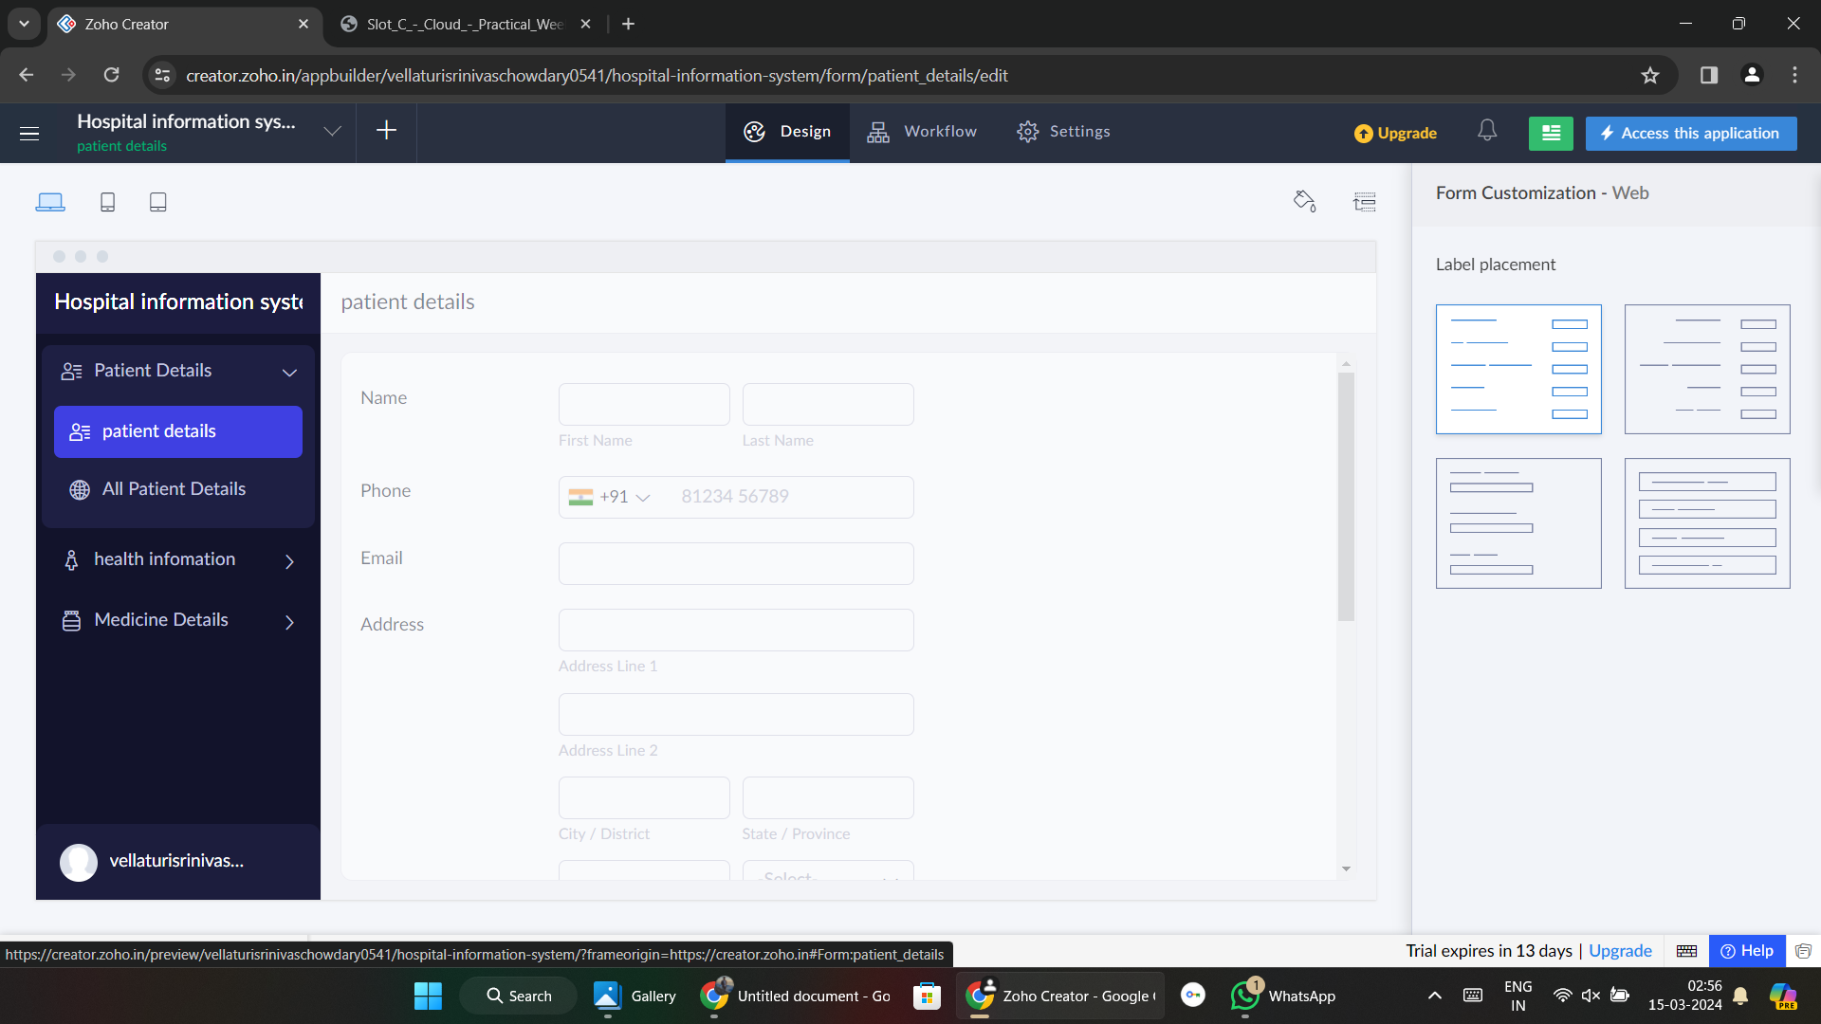

**Step 2:** add a form ‘health information’ and add details.

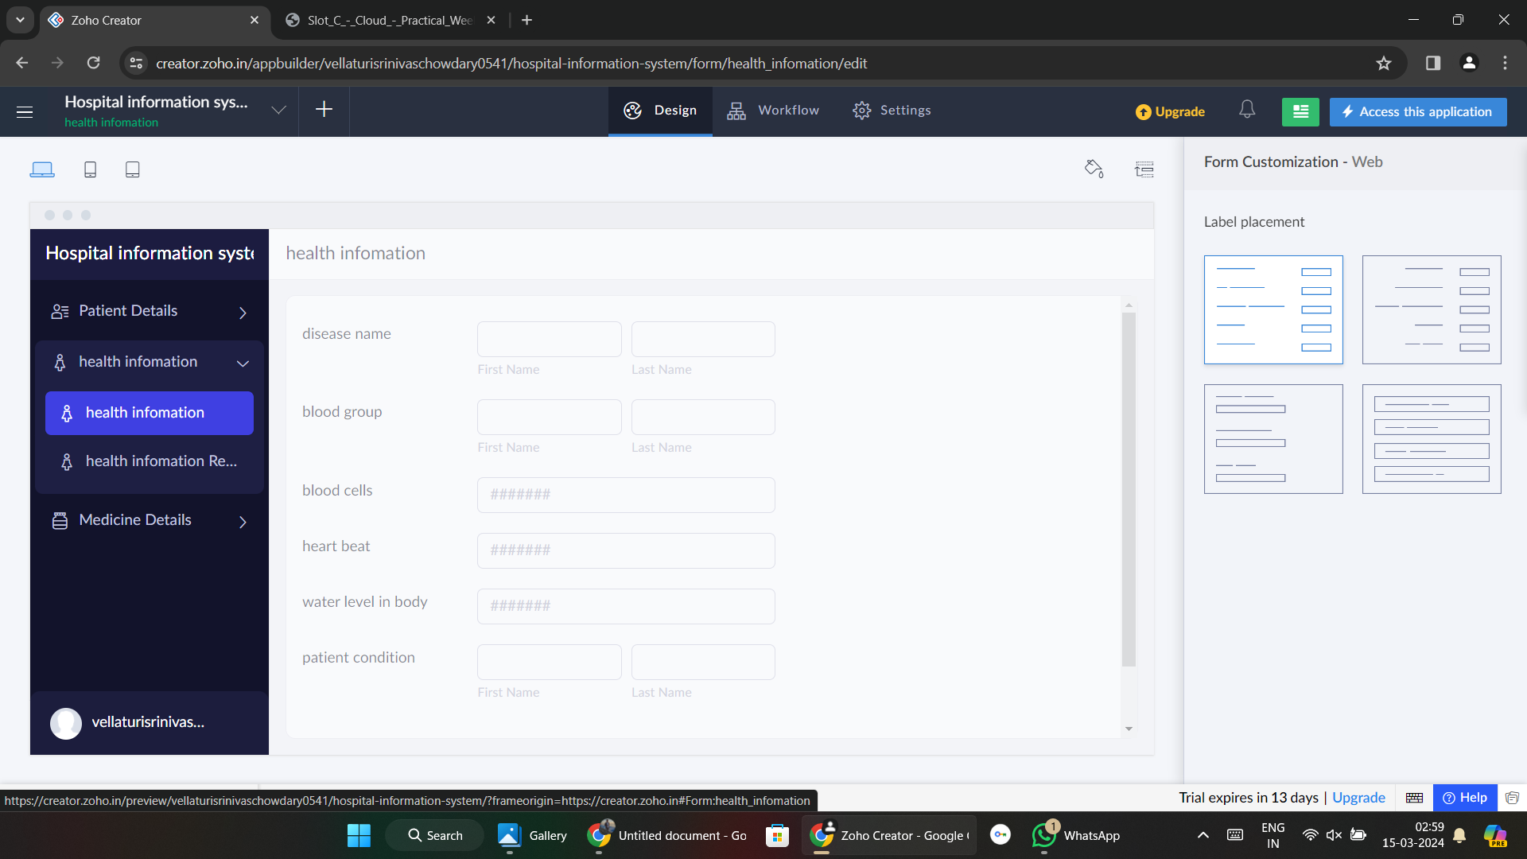

**Step 3:** add a form ‘medicine details’ and add details.

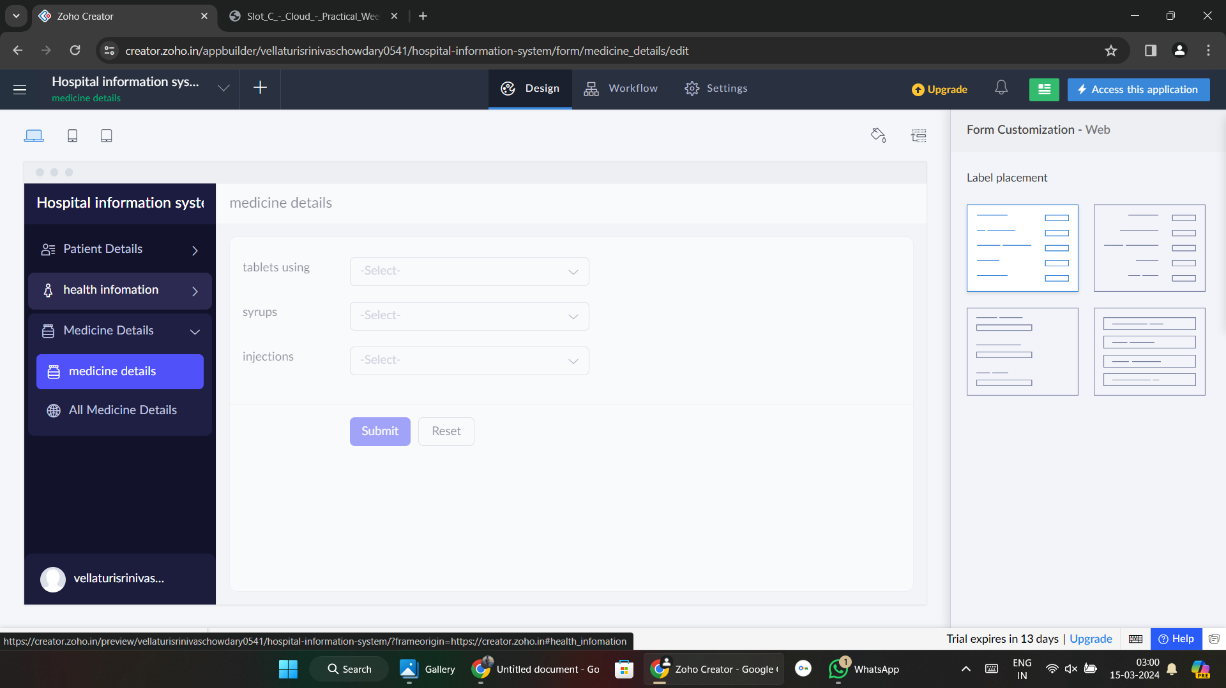

**Step 4:**Add details.

